**Order Automation System - Setup & Usage Guide**

**What This System Does**

This automation system automatically submits orders from your Google Sheets to the Harmon Portal System. Instead of manually entering each order, you simply:

1. Add order details to Google Sheets
2. Click one button
3. Watch as orders are automatically submitted to Harmon Portal

**📸 Screenshot Needed**: Before/after comparison showing manual vs automated process

**Complete Setup Guide**

**STEP 1: Download Required Software**

**1.1 Install Python**

1. Go to https://python.org/downloads
2. Download Python 3.8 or newer
3. **IMPORTANT**: During installation, check "Add Python to PATH"
4. Verify installation by opening Command Prompt and typing: python --version

**1.2 Install Google Chrome**

* Make sure Google Chrome browser is installed on your computer
* The automation uses Chrome to fill out forms automatically

**STEP 2: Create Google Cloud Service Account**

This allows the system to read and write to your Google Sheets automatically.

**2.1 Go to Google Cloud Console**

1. Visit: <https://console.cloud.google.com>
2. Sign in with your Google account

**2.2 Create a New Project**

1. Click the project dropdown at the top
2. Click "NEW PROJECT"
3. Enter project name: "Order Automation"
4. Click "CREATE"
5. Wait for project creation, then select it

**2.3 Enable Google Sheets API**

1. In the left menu, go to "APIs & Services" → "Library"
2. Search for "Google Sheets API"
3. Click on "Google Sheets API"
4. Click "ENABLE"
5. Wait for it to enable

**2.4 Create Service Account**

1. Go to "APIs & Services" → "Credentials"
2. Click "+ CREATE CREDENTIALS"
3. Select "Service account"
4. Fill in details:
   * Service account name: "order-automation"
   * Service account ID: (auto-fills)
   * Description: "For order automation system"
5. Click "CREATE AND CONTINUE"
6. Skip roles (click "CONTINUE")
7. Skip user access (click "DONE")

**2.5 Create Service Account Key**

1. Click on the service account you just created
2. Go to "KEYS" tab
3. Click "ADD KEY" → "Create new key"
4. Select "JSON"
5. Click "CREATE"
6. **IMPORTANT**: Save this file as service-account.json in a safe location

**STEP 3: Setup Your Google Sheets**

**3.1 Create Order Spreadsheet**

1. Go to <https://sheets.google.com>
2. Create a new spreadsheet
3. Name it "Order Automation"
4. Rename the first sheet to "Orders"

**3.2 Setup Column Headers**

In row 1, create these headers exactly as shown:

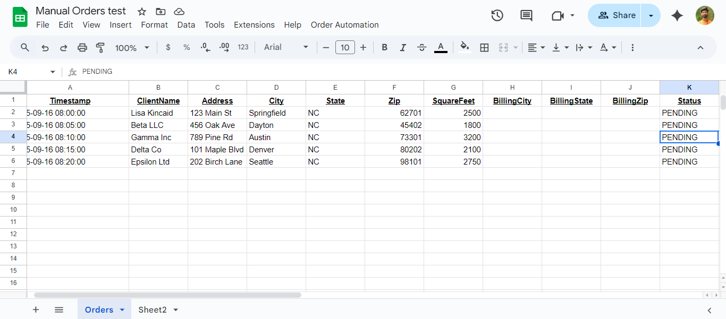**3.3 Share with Service Account**

1. Click "Share" button in top right
2. Copy the email from your service-account.json file (looks like: order-automation@your-project.iam.gserviceaccount.com)
3. Paste it in the share dialog
4. Set permission to "Editor"
5. Uncheck "Notify people"
6. Click "Share"

**3.4 Get Spreadsheet ID**

1. Look at your Google Sheets URL
2. Copy the long ID between /d/ and /edit
3. Example: https://docs.google.com/spreadsheets/d/1mAYW47RZaAHRThY35N7uh6K9J_59SO0t3hpXlg7dn5s/edit
4. The ID is: 1mAYW47RZaAHRThY35N7uh6K9J_59SO0t3hpXlg7dn5s
5. **Save this ID - you'll need it later**



**STEP 4: Install the Automation Software**

**4.1 Download Project Files**

1. Create a new folder on your computer called order-automation
2. Save all the provided files in this folder:
   * order_processor.py
   * webhook_server.py
   * google_appscript.js
   * requirements.txt
   * service-account.json (from Step 2.5)

**4.2 Install Python Requirements**

1. Open Command Prompt or Terminal
2. Navigate to your folder: cd C:\path\to\order-automation
3. Run: pip install -r requirements.txt
4. Wait for installation to complete (may take 5-10 minutes)
5. Run: playwright install chromium

**📸 Screenshot Needed**: Command prompt showing successful installation

**4.3 Update Configuration Files**

**In order_processor.py:**

* Find line 12: SPREADSHEET_ID = '1mAYW47RZaAHRThY35N7uh6K9J_59SO0t3hpXlg7dn5s'
* Replace with your spreadsheet ID from Step 3.4

**📸 Screenshot Needed**: Text editor showing the SPREADSHEET_ID line being updated

**STEP 5: Setup Google Apps Script**

**5.1 Open Apps Script**

1. In your Google Sheets, go to "Extensions" → "Apps Script"
2. Delete the default code
3. Copy and paste the entire content from google_appscript.js

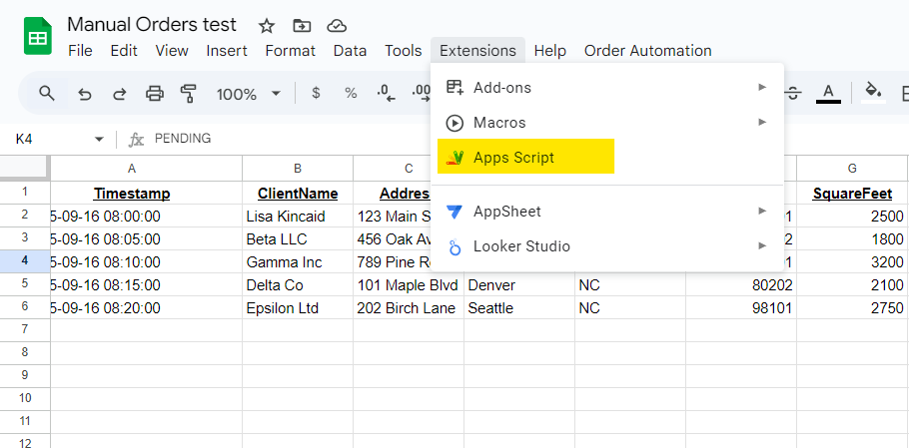

**5.2 Update Webhook URL**

1. In the code, find line 3: const WEBHOOK_URL = "https://9e33eb09ac27.ngrok-free.app/start-orders";
2. Leave it as is for now (we'll update it later)

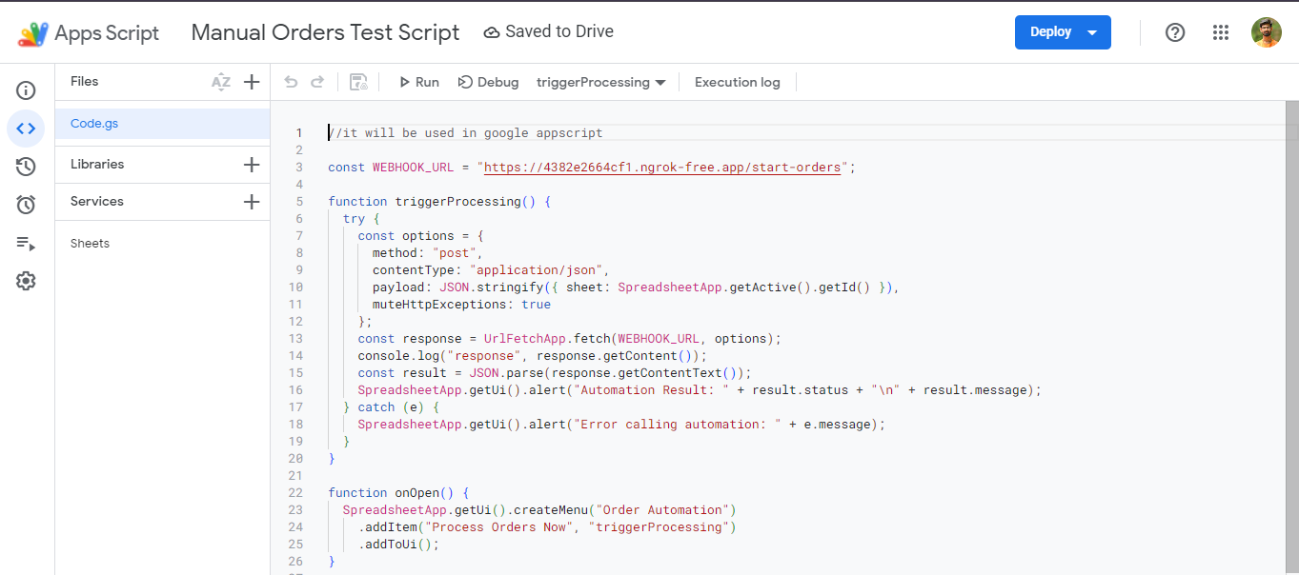

**5.3 Save and Authorize**

1. Click "Save" (disk icon)
2. Click "Run" → Select onOpen
3. Click "Review permissions"
4. Choose your Google account
5. Click "Advanced" → "Go to Untitled project (unsafe)"
6. Click "Allow"

**📸 Screenshot Needed**: Authorization dialog for the Apps Script

**STEP 6: Setup Ngrok (For Testing)**

**6.1 Create Ngrok Account**

1. Go to https://ngrok.com
2. Sign up for free account
3. Download ngrok for your operating system
4. Follow installation instructions

**6.2 Get Auth Token**

1. After signing up, go to "Your Authtoken" page
2. Copy the command shown (looks like: ngrok authtoken abc123...)
3. Run this command in Command Prompt

**How to Run the System**

**STEP 1: Start the Webhook Server**

1. Open Command Prompt
2. Navigate to your project folder: cd C:\path\to\order-automation
3. Run: python webhook_server.py
4. You should see: "Running on http://0.0.0.0:5000"
5. **Keep this window open**

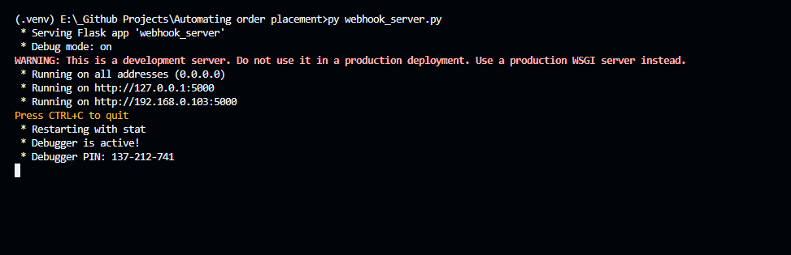

**STEP 2: Start Ngrok**

1. Open another Command Prompt window
2. Run: ngrok http 5000
3. Look for the "Forwarding" line, copy the https URL
4. Example: <https://abc123.ngrok-free.app>

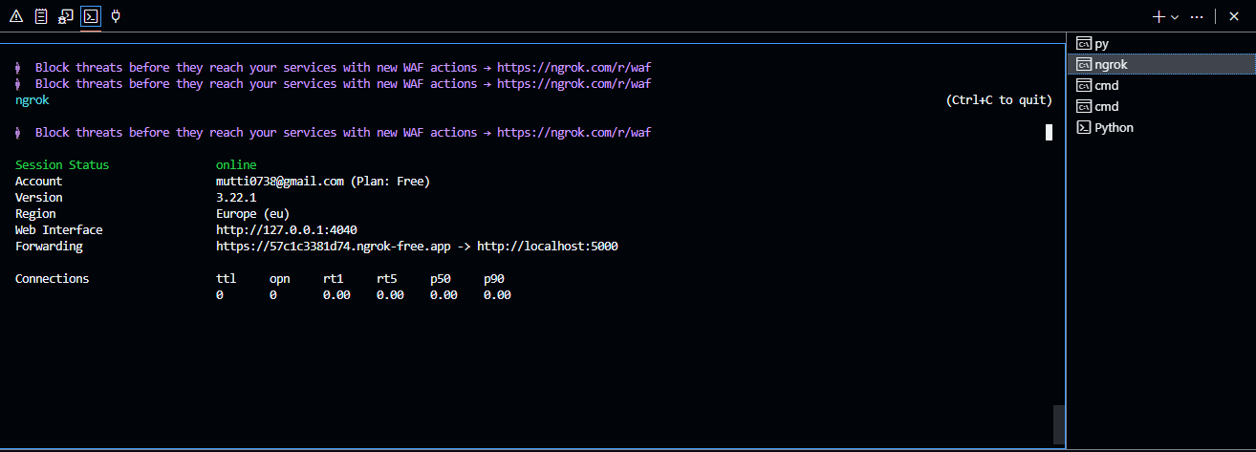

**STEP 3: Update Apps Script URL**

1. Go back to your Apps Script
2. Update line 3 with your ngrok URL + /start-orders
3. Example: const WEBHOOK_URL = "https://abc123.ngrok-free.app/start-orders";
4. Save the script

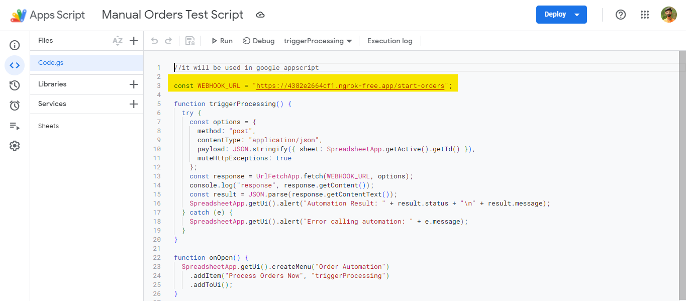

**STEP 4: Add Order Data**

1. Go to your Google Sheets
2. Add orders starting from row 2
3. Fill in all required columns (A through I)
4. Example data:

| **Client Name** | **Address** | **City** | **State** | **ZIP** | **Square Feet** | **Billing City** | **Billing State** | **Billing ZIP** |
| --- | --- | --- | --- | --- | --- | --- | --- | --- |
| John Smith | 123 Main St | Carrboro | NC | 27510 | 2500 | Carrboro | NC | 27510 |

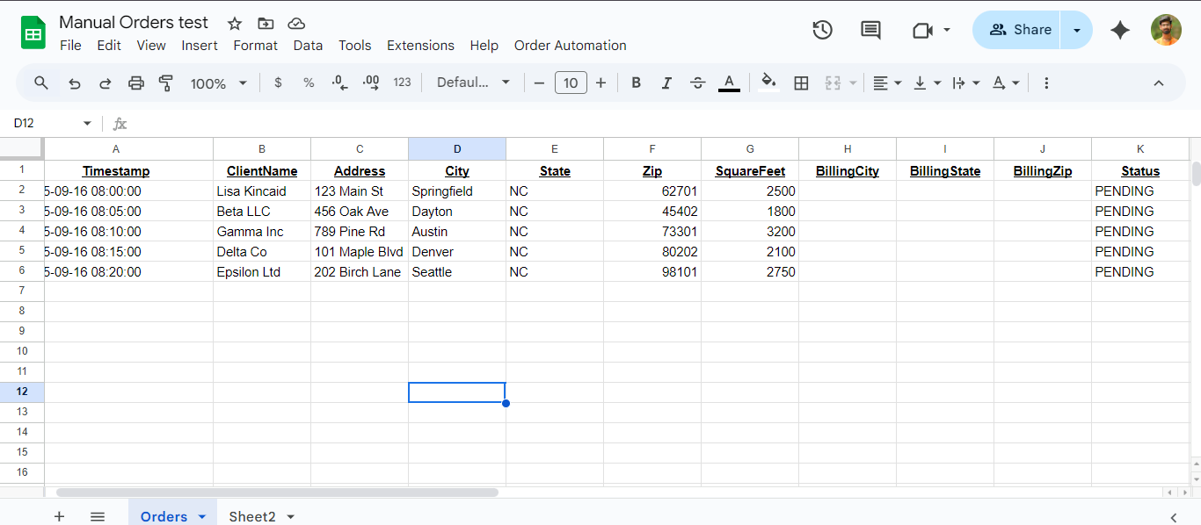**STEP 5: Process Orders**

1. In Google Sheets, you should see a new menu "Order Automation"
2. Click "Order Automation" → "Process Orders Now"
3. You'll see an alert with the result
4. Check the "Status" column for processing results

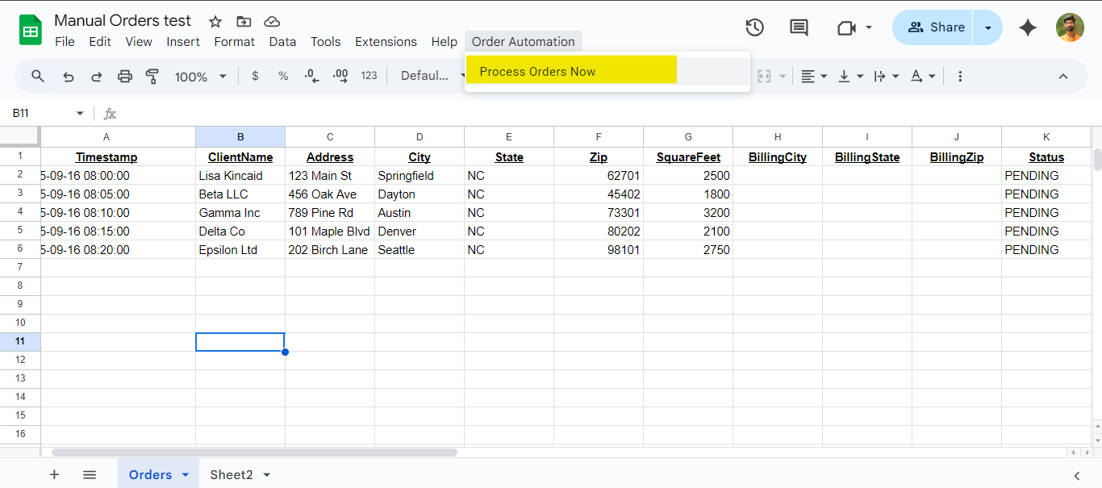

**Understanding the Results**

**Status Messages**

* **COMPLETED**: Order successfully submitted to Harmon Portal
* **ERROR: [description]**: Something went wrong, see error details
* **ORDER_SUCCESS**: Alternative success message

**Monitoring Progress**

1. Watch the Command Prompt where webhook_server.py is running
2. You'll see logs like:
3. Row 2: ORDER_SUCCESSRow 3: ORDER_SUCCESS Row 4: ERROR: Timeout waiting for element

**Troubleshooting Common Issues**

**"Error calling automation"**

**Problem**: Google Sheets can't reach the webhook server **Solutions**:

1. Make sure webhook_server.py is running
2. Check that ngrok is running
3. Verify the webhook URL in Apps Script is correct
4. Make sure the URL ends with /start-orders

**"Google Sheets API error"**

**Problem**: Can't access your spreadsheet **Solutions**:

1. Check that service-account.json is in the correct folder
2. Verify the spreadsheet is shared with the service account email
3. Confirm the SPREADSHEET_ID is correct in order_processor.py

**"Timeout" errors during processing**

**Problem**: Harmon Portal is slow or elements not found **Solutions**:

1. Check your internet connection
2. Try running again (sometimes the portal is slow)
3. Verify your Harmon Portal credentials are correct

**Browser doesn't appear**

**Problem**: You want to see the automation in action **Solution**: The browser runs in the background by default. This is normal.

**Daily Usage Instructions**

Once everything is set up, daily usage is simple:

**Every Day:**

1. **Start the system**:
   * Run python webhook_server.py
   * Run ngrok http 5000 (in another window)
   * Update Apps Script with new ngrok URL if it changed
2. **Add your orders** to Google Sheets
3. **Click "Process Orders Now"** in the Order Automation menu
4. **Check results** in the Status column

**Tips for Best Results:**

* Add orders one at a time initially to test
* Always fill in all required columns
* Double-check addresses and ZIP codes
* Process orders during business hours when Harmon Portal is most stable

**Data Format Requirements**

**Required Columns (must be filled):**

* **Client Name**: Customer's full name
* **Address**: Street address
* **City**: City name
* **State**: Two-letter state code (NC, CA, etc.)
* **ZIP**: 5-digit ZIP code
* **Square Feet**: Property size in numbers only

**Optional Columns:**

* **Billing City**: Defaults to same as property city
* **Billing State**: Defaults to same as property state
* **Billing ZIP**: Defaults to same as property ZIP

**Security & Safety**

**Important Security Notes:**

1. **Never share your service-account.json file** - it contains sensitive credentials
2. **Keep your Harmon Portal password secure** - it's stored in the code
3. **Use ngrok only for testing** - for production, use a proper server
4. **Regularly update your passwords**

**File Backup:**

* Keep a backup of your service-account.json file
* Save your spreadsheet ID somewhere safe
* Export your Google Sheets regularly

**Summary**

Once set up, your daily workflow is just:

1. ✅ Start the servers (webhook_server.py and ngrok)
2. ✅ Add orders to Google Sheets
3. ✅ Click "Process Orders Now"
4. ✅ Check results

The initial setup takes about 30-60 minutes, but saves hours of manual work every day!